SAP JAM

SAP Jam is a cloud-based enterprise social networking suite and collaboration app that helps users connect with employees, partners, and customers. SAP Jam can be utilized to protect company data by collaborating over a secure network. The app helps employees to find colleagues and experts to collaborate with, as well as providing a place to manage and organize projects.

SAP Jam also offers a platform for client-facing teams to communicate with partners and clients, discussing topics in online groups and reducing issue resolution time.

Employees can share files, documents, screen recordings, videos and more with new hires. New hires use SAP Jam’s groups and communities to connect with subject experts and colleagues to quickly find answers to queries.

Overview of SAP JAM Benefits:

SAP Jam provides social collaboration:

* In your business, productivity, and mobile apps, or directly in the app
* To drive measurable results
* Across the business with a secure social platform to avoid social silos and to deliver a seamless experience

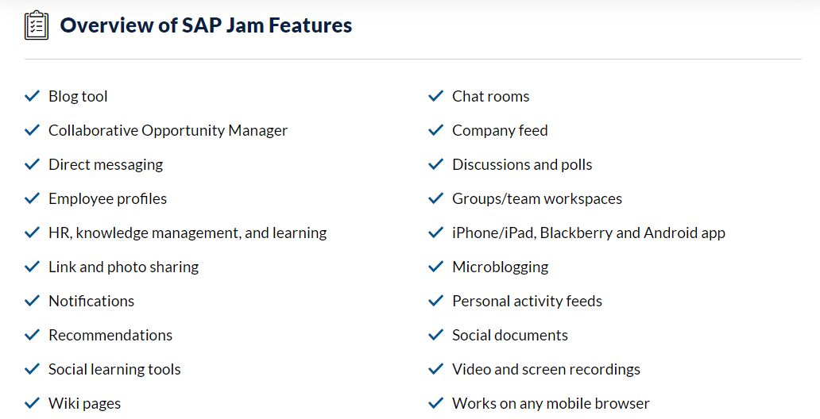

How much does SAP JAM Cost?

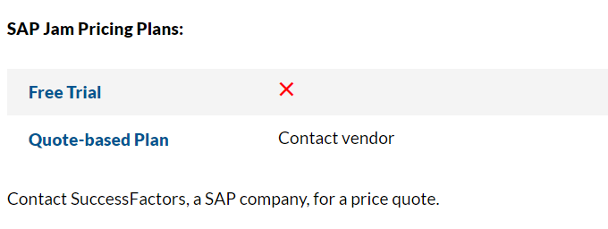

SAP Jam Collaboration**

To connect your chatbot to SAP Jam Collaboration, you need to be an SAP Jam administrator.

For information about SAP Jam Collaboration, please see [SAP Jam Collaboration](https://help.sap.com/viewer/p/SAP_JAM_COLLABORATION) on SAP Help Portal.

Only the button type postback is supported. The button types web_url and phone number are not supported. If the button types web_url and phone number are used, the buttons will behave like postback buttons.

# SAP Jam integrated with SuccessFactors Platform

When SAP Jam Collaboration instances are integrated with SuccessFactors Platform, user access to SAP Jam is granted by the company administrator through SuccessFactors platform administration settings using role-based permissions (RBP).

The default configuration for this integration provides all users configured with access through SuccessFactors platform with access to SAP Jam. However, a company administrator can override this default configuration and choose which roles, users, or groups of users receive access to SAP Jam. Single sign-on (SSO) is also available with this integration.

## Request SAP Jam integration with SuccessFactors Platform

SAP Professional Services configures your SAP Jam instance integrated with SuccessFactors Platform during provisioning, but if this is not done, you can request the integration by creating a support ticket in the Support Portal. To do this, access the [SAP Support Portal[Information published on SAP site](http://help.sap.com/disclaimer?site=https://support.sap.com/home.html)](http://help.sap.com/disclaimer?site=https://support.sap.com/home.html) and click Report an Incident. In your report, include the following information:

* Request Summary: SAP Jam Integration Request [Customer Organization Name]
* Product: SAP Jam
* Category: Configuration Change Request

In the Request Details, make sure to include the following information:

For more information please refer this link: <https://help.sap.com/viewer/u_admin_help/e8148fe3b68549ca864158e5e8aca371.html>

Automatic user provisioning

SAP Jam gets its user information from SuccessFactors Platform via a data transfer. The following table explains how SAP Jam employee profile attributes get mapped from SuccessFactors Platform.

| SuccessFactors Platform to SAP Jam user attribute mappings | | |
| --- | --- | --- |
| **SAP Jam Collaboration attribute** | **SF Foundation import attribute** | **Notes** |
| Address Line 1 | ADDR1 |  |
| Address Line 2 | ADDR2 |  |
| Business Phone | BIZ_PHONE |  |
| City | CITY | Used by Dynamic Member List feature. |
| Country | COUNTRY | Used by Dynamic Member List feature. |
| Department | DEPARTMENT | Used by Dynamic Member List feature. |
| Division | DIVISION | Used by Dynamic Member List feature. |
| Direct Report |  | Auto-computed from all users with Manager = current USERID. |
| Email | EMAIL |  |
| Fax | FAX |  |
| Jobcode | JOBCODE | Used by Dynamic Member List feature. |
| Job Title | TITLE | **Real-time sync**: The data sync of this field is done in near-real time. |
| Locale | DEFAULT_LOCALE | **Real-time sync**: The data sync of this field is done in near-real time, allowing immediate language switching in the UI. |
| Location | LOCATION | Used by Dynamic Member List feature. |
| Manager | MANAGER |  |
| First Name | FIRSTNAME | **Real-time sync**: The data sync of this field is done in near-real time. |
| Last Name | LASTNAME | **Real-time sync**: The data sync of this field is done in near-real time. |
| Photo | PHOTO |  |
| Salutation | SALUTATION |  |
| Start Date | HIREDATE | Used by Dynamic Member List feature. |
| State | STATE | Used by Dynamic Member List feature. |
| Status | STATUS |  |
| Suffix | SUFFIX |  |
| Timezone | TIMEZONE | **Real-time sync**: The data sync of this field is done in near-real time. |
| UserId | USERID | Auto-generated by SuccessFactors Platform; for internal system use. |
| UserName | USERNAME |  |
| Zip Code | ZIP | Used by Dynamic Member List feature. |
| Custom Fields 1-15 | CUSTOM01 - CUSTOM15 | Used by Dynamic Member List feature.  **Note**  To ensure your company's compliance with data privacy regulations, please ensure that sensitive personal data is not stored in any profile fields. Sensitive personal data is information on racial or ethnic origin, political opinions, religious or philosophical beliefs, trade-union membership, health or sexual orientation, bank account and credit card data, genetic data and biometric data for the purpose of uniquely identifying a natural person. |

# Single sign-on and Deep Linking:

Deep linking occurs when a hypertext link points to a page on a web site other than its home page that involves some navigation into the structure of the web site.

For SAP Jam Collaboration, deep linking is dependent on the single sign-on (SSO) configuration, which is typically done by Professional Services upon implementation. This can be, for example, a standard SAML 2.0-based single log on. If SSO is configured correctly, most SAP Jam URLs should take the user directly to the indicated SAP Jam page after a series of redirects from SAP Jam to the company IDP and back to SAP Jam.

## SAP Jam handling of deep linking

In normal SAP Jam usage, a user logs in and SAP Jam sets a cookie in the user's browser that indicates which company the user belongs to. When a user clicks on a deep link such as https://jam#.sapjam.com/groups/wall/0Hm4gyKS4qegqd2qkkl8Xf, SAP Jam looks for that cookie, but it might not be found if:

* The user is new to SAP Jam and hasn't logged in before.
* The user's browser configuration is set to delete all cookies on shut down.
* The user has manually deleted the required cookie or all cookies from their browser.

So, when a user clicks a deep link for a page within SAP Jam, it looks for the cookie that identifies which company a user belongs to. One of two things happen:

1. If SAP Jam finds the cookie, it will know which company the user belongs to and it will forward the user to their company specific SSO page.
2. If SAP Jam cannot find the cookie, it will do one of two things:

* SAP Jam will determine which company the content belongs to by analysing the URL. There are two possible actions:

1. If the URL is to a private internal group, SAP Jam forwards the user to that company's SSO page.
2. If the URL is to an external group, a challenge is encountered because internal users (company employees) and external users (guest members) are authenticated in different SSO log-in pages. To deal with this, SAP Jam presents a screen to the user, asking them if they are an employee of the company or if they are a guest:
3. If they answer that they are an employee, they are forwarded to the employees' SSO log on page.
4. If they answer that they are a guest, they are forwarded to the guests' SSO log on page.
   * If SAP Jam finds one of the very few URLs that it cannot determine what company the user belongs to, such as happens if the link is to a user's home page (which is always something like https://jam4.sapjam.com/auth/status), then there needs to have been extra information added to the URL to allow deep linking to work properly even in such a situation. For example:
     1. [https://[jam4.sapjam.com]/c/[CompanyID.cubetree.biz].companyname.biz/auth/status](https://[jam4.sapjam.com]/c/%5bCompanyID.cubetree.biz%5d.companyname.biz/auth/status)

 where:

* [jam4.sapjam.com] is your associated data center.
  + 1. https://jam#.sapjam.com/auth/status?companyId=[CompanyID_here]&idp=[SuccessFactors_data_center_here] where:
  + # is your associated SAP Jam data center.
  + [CompanyID_here] is your SuccessFactors Company ID
* [SuccessFactors_data_center_here] is your SuccessFactors Data Center URL (e.g., performancemanager4.successfactors.com)

Once the user successfully authenticates against the corporate SSO they are#& SuccessFactors Platform feature that is generally set up by Professional Servicesidp=[SuccessFactors at the time of implementation. data center]